**Lab 3 Exception Handling Screenshots**

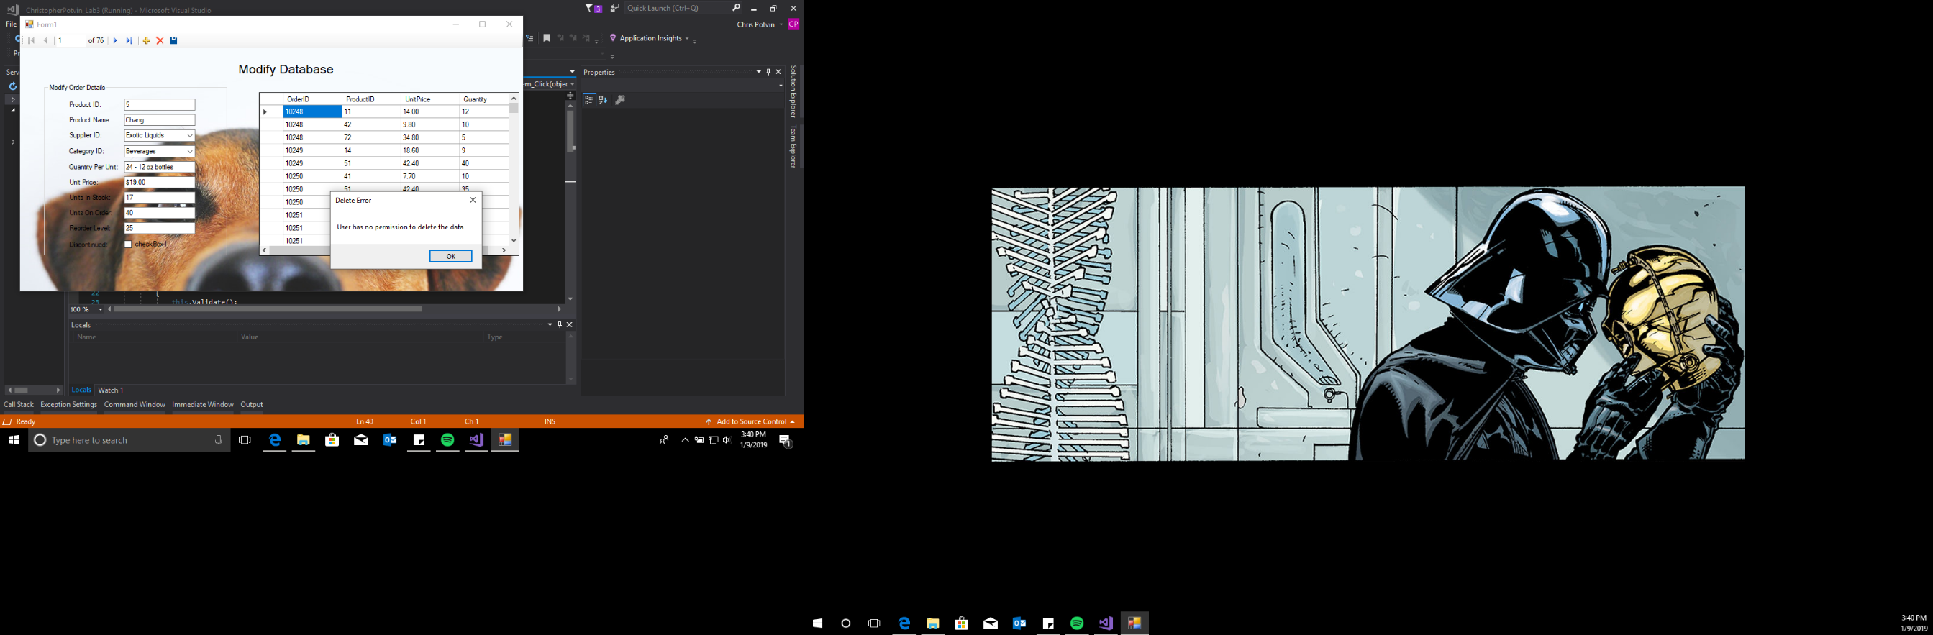SQL Exception for the user cannot delete and save the customer (1)

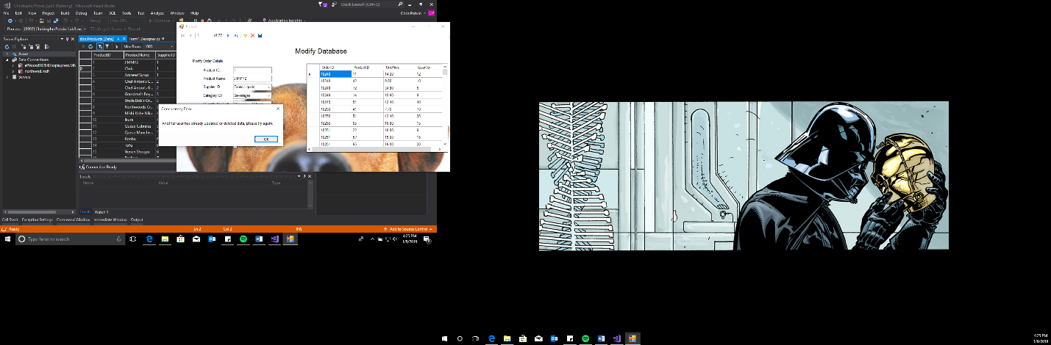

DB Concurrency Exception so that when a user is connected to the DB via the SQL server and makes a change, the user cannot save their change while in the application without the error (2)

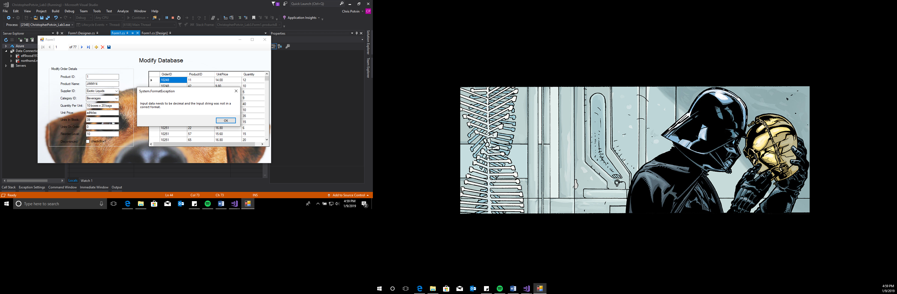

Format Exception in the unit price so that if the user is inputting a string of characters it will throw the exception because it’s supposed to a be a decimal (3)

Format Exception that requires the user to enter a product ID that is above zero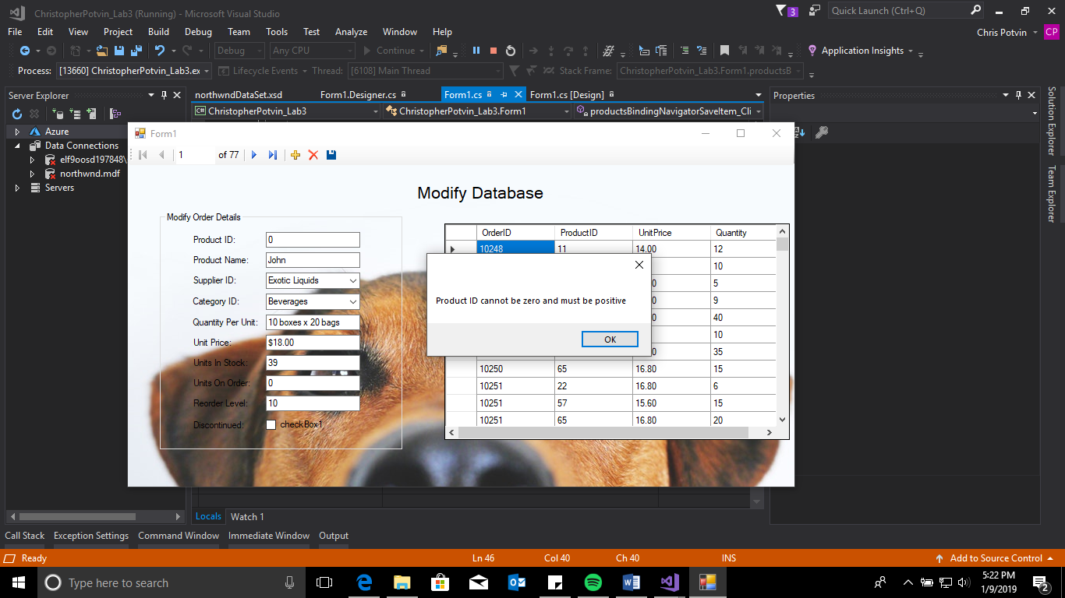 and must be positive (4)

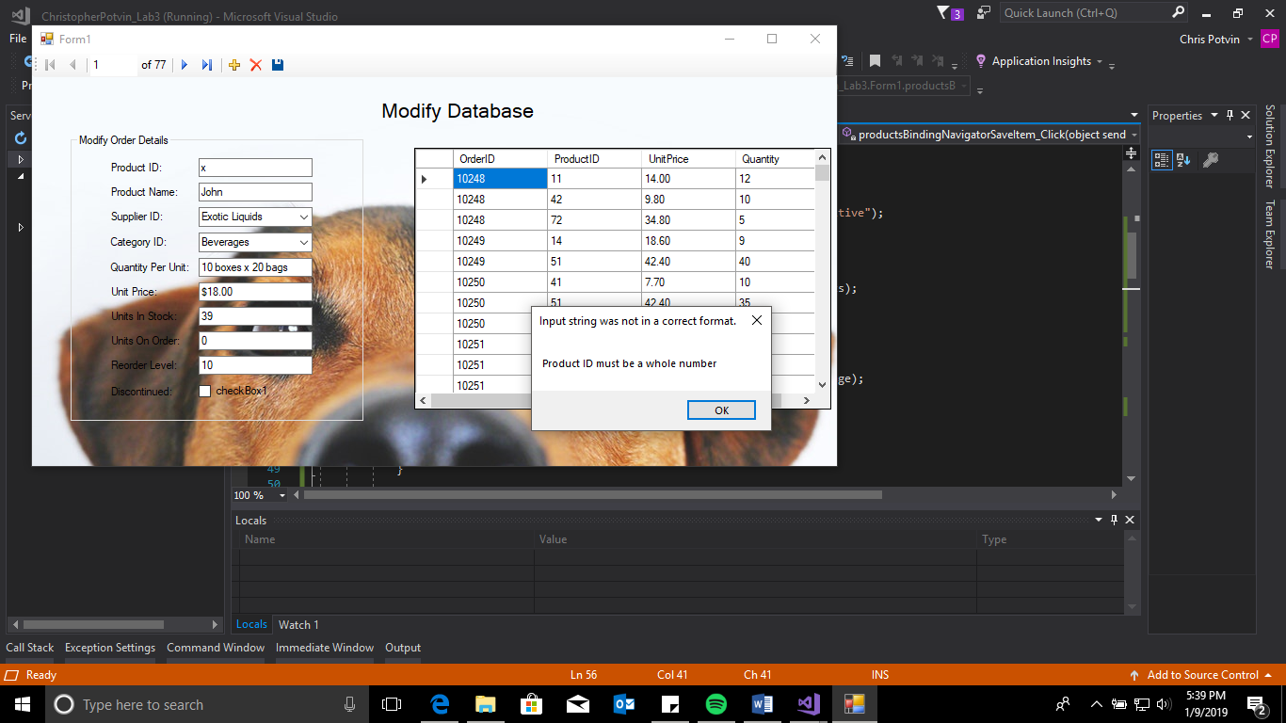

Format Exception that requires the user to enter a product ID that a whole number (5)